Module7 Assignment1
6) Explain How You Coded the Perceptron
The perceptron was coded in Python using three inputs and three corresponding weights. The program calculates a weighted sum by multiplying each input by its corresponding weight and adding the results. The weighted sum is then passed to the activation function to produce the output. The program also calculates the squared error between the expected and actual outputs. The batch_test_perceptron() function tests the weights on the complete training dataset and calculates the Mean Squared Error (MSE). The MSE was used to evaluate the performance of the weights during the experiments.
a) Why Was a Linear Activation Function Used?
A linear activation function was used because it produces continuous output values instead of only 0 or 1. This allows the program to calculate the error and measure how changes in the weights affect the output. This is useful when training the perceptron using MSE and gradient descent. The linear activation function allows the output to get close to 0 or 1 rather than being immediately limited to binary values.
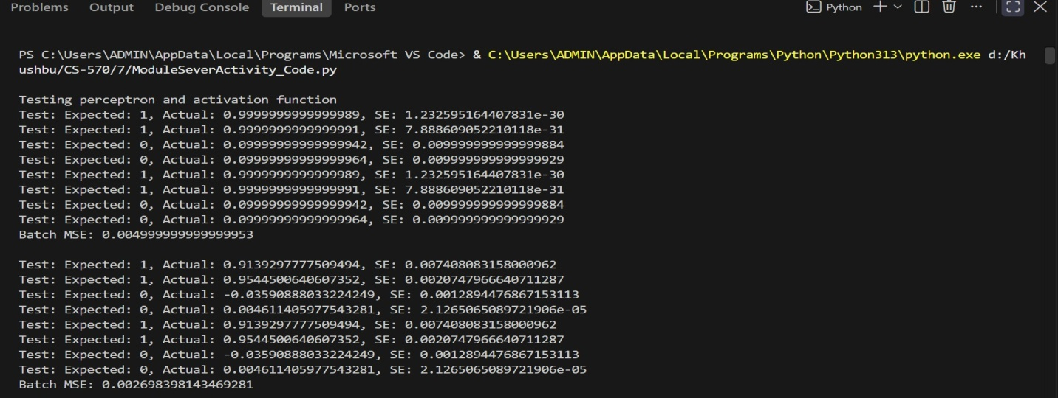
7) Discuss How You Used Learning Rate While Brute Force Training the Perceptron
a) What weight range did you use?
I used two weight ranges during the brute force experiments: (-1, 1) and (-2, 2). The range (-1, 1) was tested with learning rates of 0.1 and 0.05. The range (-2, 2) was tested with a learning rate of 0.1.
b) How did learning rate impact training?
The learning rate determined the step size used when searching for weight values. Using a learning rate of 0.1 resulted in fewer weight combinations being tested than a learning rate of 0.05. A smaller learning rate used smaller steps and therefore required more epochs to search through the possible weights.
c) How many epochs did it take to train?
The brute force experiments produced the following results:
1) Weight range (-1, 1), learning rate 0.1: 7,812 epochs
2) Weight range (-1, 1), learning rate 0.05: 61,543 epochs
3) Weight range (-2, 2), learning rate 0.1: 47,182 epochs
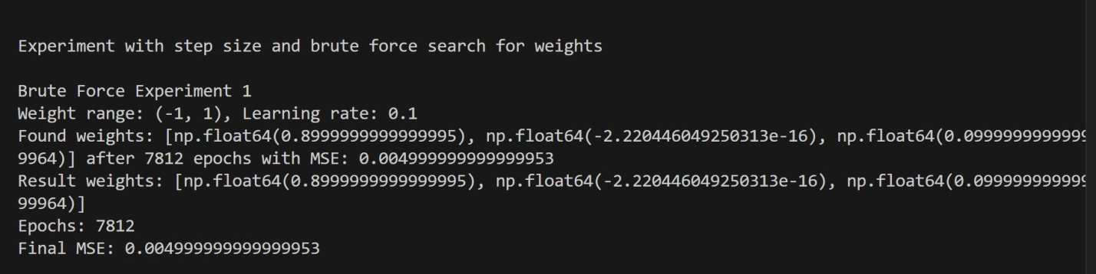
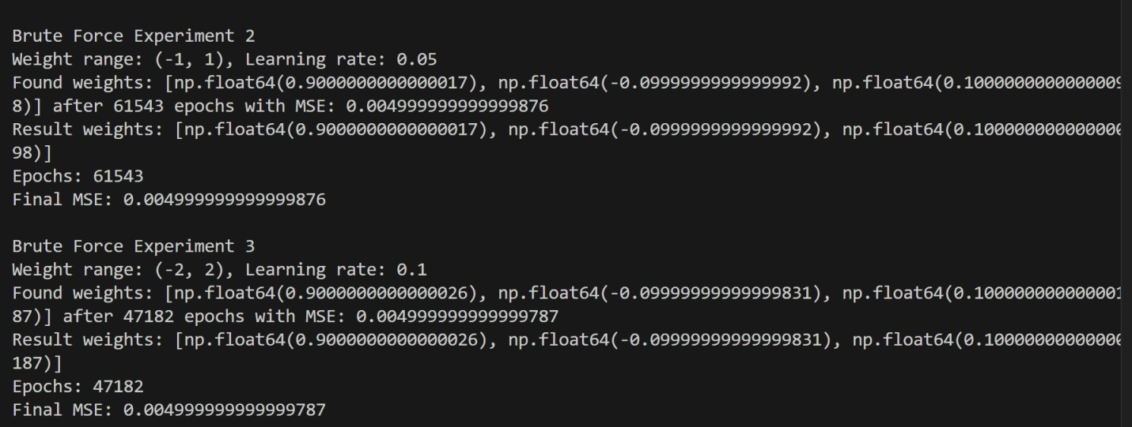
d) Were you able to train the perceptron with the XOR data set? What happened?
No. The perceptron was not able to find suitable weights for the XOR data set after 8,000 epochs. This occurred because the XOR problem cannot be solved by a single linear perceptron. The positive and negative outputs cannot be separated using a single linear decision boundary.
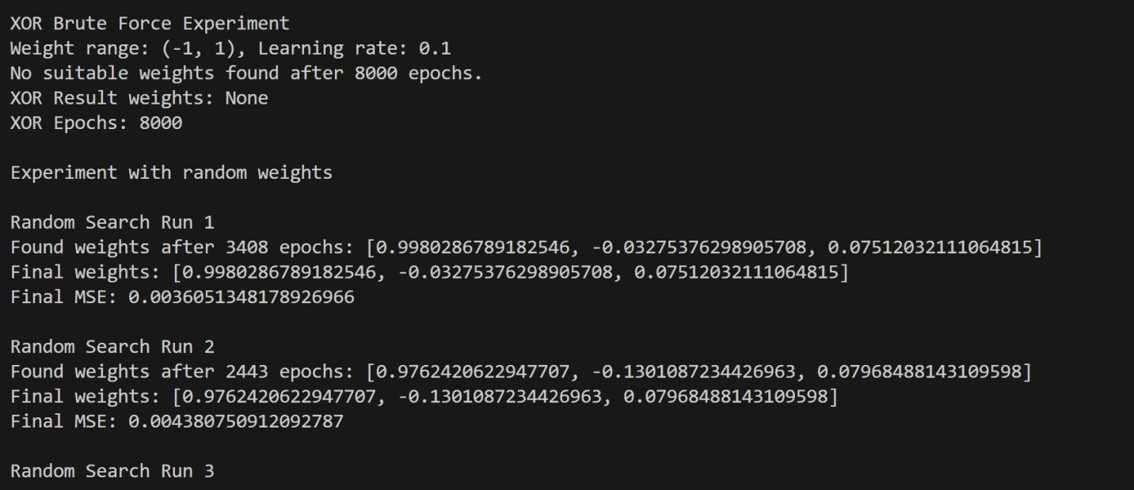
8) Discuss How You Worked With Random Weights for Training the Perceptron
a) What was the final MSE and epoch count for each call?
The perceptron was trained ten times using random weight selection. The final MSE and epoch count for each run were:
- Run 1: Final MSE = 0.0036051348178926966, Epochs = 3,408
- Run 2: Final MSE = 0.004380750912092787, Epochs = 2,443
- Run 3: Final MSE = 0.003464016006050767, Epochs = 1,643
- Run 4: Final MSE = 0.0023216759692911023, Epochs = 1,849
- Run 5: Final MSE = 0.004319971897728838, Epochs = 1,661
- Run 6: Final MSE = 0.003901808705757615, Epochs = 3,256
- Run 7: Final MSE = 0.00367757035349863, Epochs = 141
- Run 8: Final MSE = 0.004612671257163783, Epochs = 1,272
- Run 9: Final MSE = 0.0011794343870748377, Epochs = 1,356
- Run 10: Final MSE = 0.00383259320842918, Epochs = 2,326
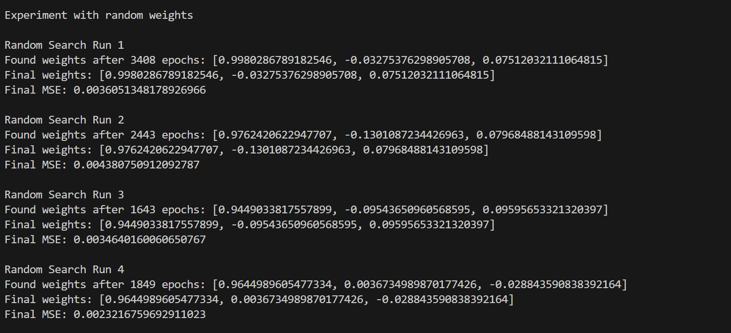
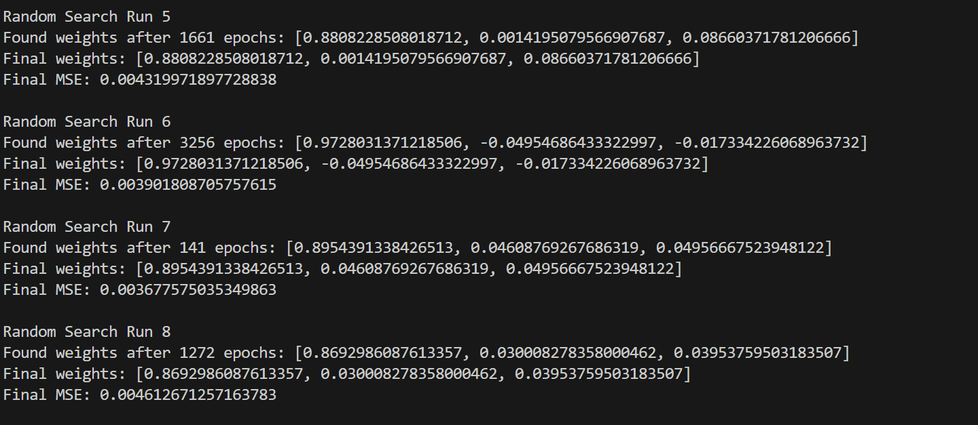
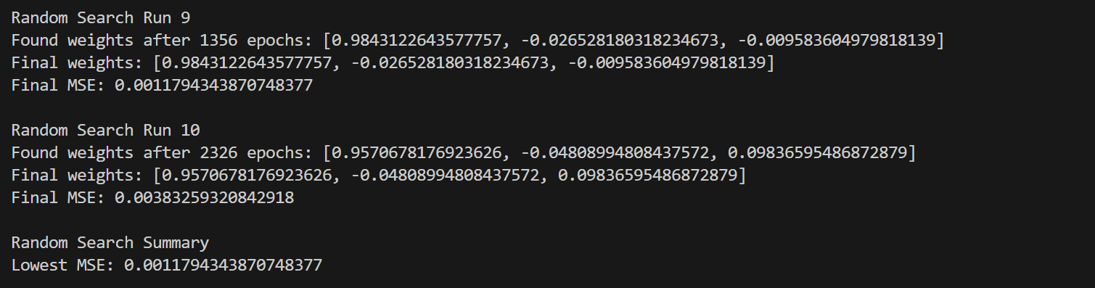
b) What is the lowest MSE you were able to achieve using random weight selection?
The lowest MSE achieved using random weight selection was 0.0011794343870748377. This result was obtained during Random Search Run 9.
c) How many epochs did it take to train?
The run that achieved the lowest MSE, Random Search Run 9, required 1,356 epochs to train.
d) Why can't you use random guesses to select the weights?
Random weight selection cannot be relied upon because the results are inconsistent. Different randomly selected weights produce different MSE values and require different numbers of epochs to train. For example, some runs required more than 3,000 epochs, while another run required only 141 epochs. Therefore, randomly guessing weights does not guarantee that the perceptron will achieve the lowest possible error efficiently. A systematic training method is more reliable for finding appropriate weights.
9) Explain how you used a batch gradient descent algorithm to train the perceptron.
I used the Batch Gradient Descent algorithm to train the perceptron. In this method, the model calculates the error using the entire training dataset and then updates the weights after processing all training examples in one batch. The training continued until the target MSE was reached.
a) How many epochs did it take to train?
The number of epochs depended on the learning rate used:
- Learning rate 0.01: 383 epochs
- Learning rate 0.1: 20 epochs
- Learning rate 0.05: 39 epochs
The learning rate of 0.1 reached the target MSE in the fewest epochs.
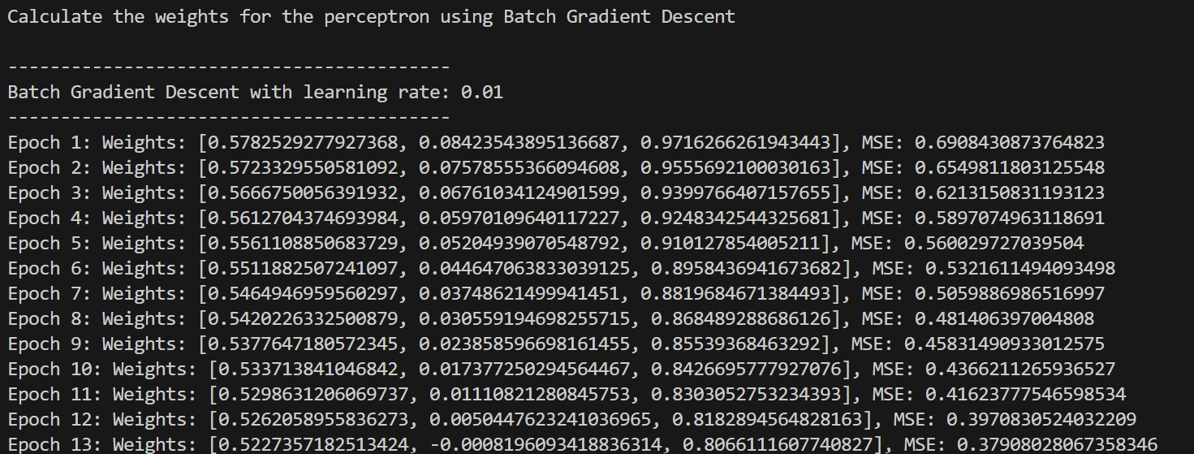
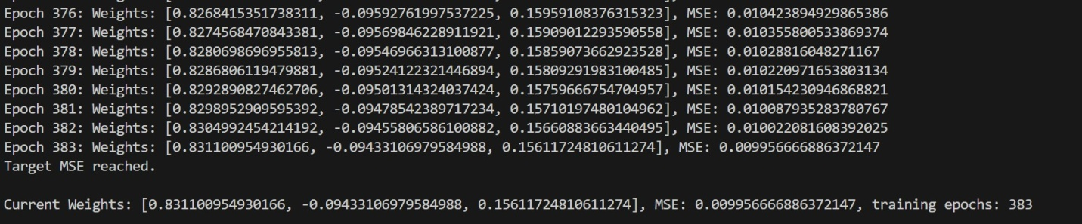
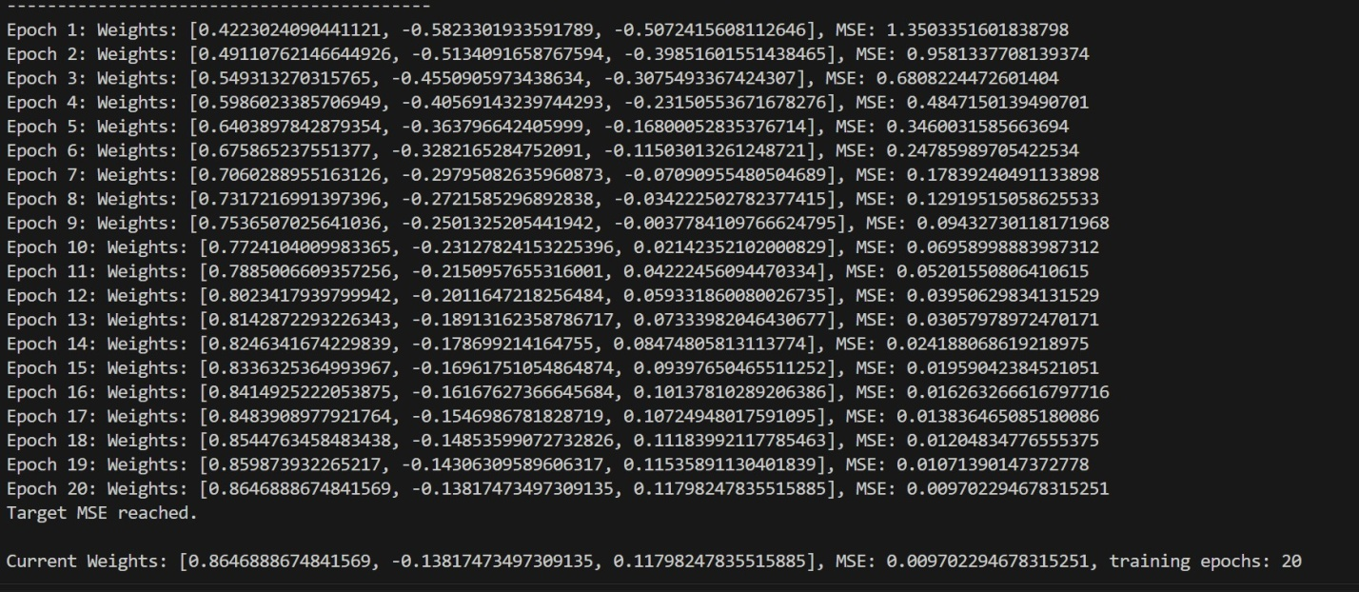
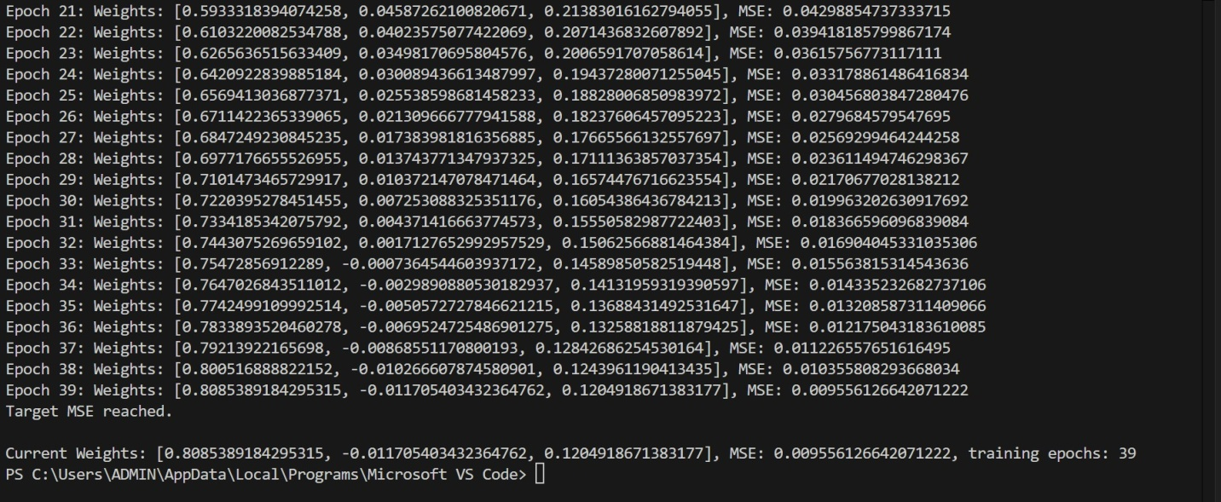
b) What learning rates did you use?
The learning rates used for the Batch Gradient Descent experiments were:
- 0.01
- 0.05
- 0.1
These experiments show that the learning rate affects the speed of training. In this experiment, the learning rate 0.1 reached the target MSE faster than the other learning rates.
10) Explain how the batch_gradient_estimation() function determines the gradient
The batch_gradient_estimation() function determines how each weight should be adjusted by calculating the error across the entire training dataset. For each training example, it compares the expected output with the actual perceptron output and uses this error to calculate the contribution to the gradient for each weight. These values are accumulated for all training examples and then used to update the weights in the direction that reduces the overall Mean Squared Error (MSE).
a) What is a gradient: A gradient represents the direction and rate of change of the error with respect to the model weights. It helps determine how each weight should be adjusted to reduce the error. During gradient descent, the weights are updated in the direction that reduces the MSE.
11) Explain How the Stochastic Gradient Descent (SGD) Algorithm Is Different from the Batch Gradient Descent Algorithm
a) How would this algorithm train your perceptron?
Batch Gradient Descent calculates the gradient using the entire training dataset before updating the weights. In contrast, Stochastic Gradient Descent (SGD) processes one training example at a time and updates the weights immediately after calculating the error for that example.
Therefore, SGD would train the perceptron by selecting one input-output example, calculating the perceptron output and error, estimating the gradient, and immediately updating the weights. The process would then continue with the next training example.
b) What functions in the provided template code would have to change and how?
The main function that would need to change is batch_gradient_estimation(). Instead of calculating and accumulating the gradient for all training examples, the function would calculate the gradient using one training example at a time. The batch_gradient_descent() function would also need to change so that the weights are updated immediately after processing each individual training example rather than waiting until the entire batch has been processed.
In summary, the perceptron and activation functions would remain the same. The main changes would be made to the gradient estimation and training functions so that weight updates occur after each individual training example.
12) References
Goodfellow, I., Bengio, Y., & Courville, A. (2016). Deep learning. MIT Press.
Scikit-learn developers. (n.d.). Neural network models (supervised). Scikit-learn. Scikit-learn Neural Network Models Documentation

